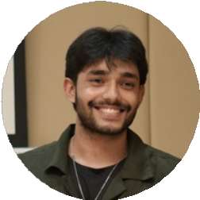
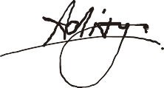
ADITYA KULIYAL
Concept artist & Illustrator

Seeking employment as a concept artist to use skills with computers and the visual arts for the benefit of your company.

Contact
Experience

7505908778
adityakuliyal001@gmail.com
Dev Enterprises
Illustrator/Graphic Designer
2023 - 2024

Clement Town, Dehradun
L:linkedin.com/in/aditya-kuliyal-56ba51363
Designed marketing collateral, logos, and banners for clients.experience in character design, digital painting, visual storytelling, and multi-style artwork creation, skilled in composition, color theory, lighting, and high-quality rendering.

Menstrupedia

Education
Illustrator/visualizer
2025- present

Bachelor of Design
Specialization in Animation & Gaming Graphic Era Hill University
Clement Town, Dehradun 2021-2025

Matriculation
DSB International Public School Rishikesh(CBSE)
2018

Intermediate
DSB International Public School Rishikesh(CBSE)
2021
Strengths
Staying Organized collaborative and creative Meeting deadlines technical know-how

Hobbies
Sketching Playing Football
Martial Arts - Boxing and MMA
Designed storyboards and illustrations for Trubuddy comics. Design covers for comic books
Designed assets, backgrounds animations for game(Wisewarrior)
Developed high-quality illustrations, character designs, cartoons, and environment artwork for digital and print media, ensuring style consistency, visual appeal, and timely delivery through effective cross-functional collaboration.
Skills
Concept art, Character design, Storyboarding, Illustrations, background design.
Software: Adobe Photoshop, Illustrator, Procreate, Krita, Clip Studio Paint, Adobe Animate, Premiere Pro, After Effects,Tiled
Knowledge
Cinematography (camera angles, shot, color theory) Graphic design (brand guidelines, logos, posters)
3D (lighting, animation, modeling ) motion graphics

Achievements
worked on animations of Trubuddy Wisewarrior game on Tiktakgo.
1st position in Regional Painting Competition , Roorkee 2018
Artworks displayed at 6th Congress of Disaster Management, GEHU 2023
Portfolio link
Aditya Kuliyal

